PETITION FOR SUBORDINATE SERVICE DISTRICT
WE, the undersigned property owners of the land herein described below, herby petition the Board of Supervisors of the Township of KABETOGAMA of ST. LOUIS County, Minnesota, to consider the creation of a Subordinate Service District for wastewater collection, treatment and management services, pursuant to Minnesota Statutes, 365A.
THE PROPOSED SUBORDINATE SERVICE DISTRICT is described as Service Area __ as indicated on the attached map (Exhibit ____), located in Township 69 North, Range 21 West, Section __: a portion of the Town of Kabetogama including the parcel code numbers on the attached map (Exhibit ____).
THE PURPOSE of said Subordinate Service District will be to:
Identify wastewater needs, provide for the planning, construction, financing, hook-up and long term operation and maintenance of wastewater collection and treatment systems(s) in order to provide for accountability and continuity for the benefit of all the property owners in the Service
District area identified above.

WE, the undersigned property owners, understand that the services provided by this Subordinate Service District will be financed by the property owners benefited within this said Subordinate Service District.

Petitioner:

Parcel Code #:

Legal Description:

Dated_______________

SIGNATURE(S) of all owners of the above property MAILING ADDRESS
_____________________________________________________________________________
______________________________________________________________________________
______________________________________________________________________________

Please return this petition in the self addressed envelope ASAP
Thank You
_____________, Kabetogama Clean Water Initiative Committee Member

Exhibit A1
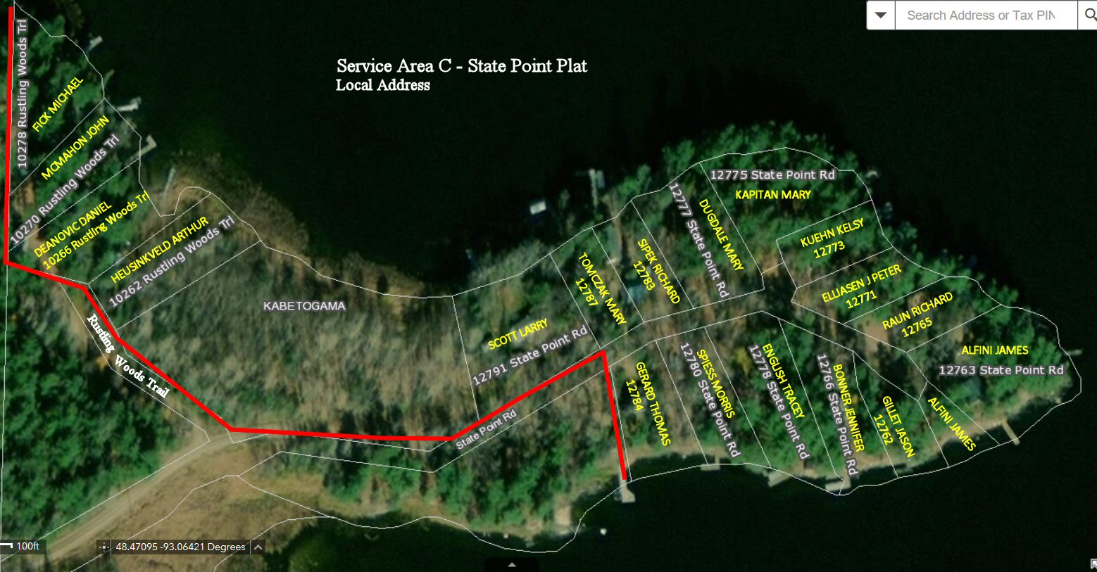

Exhibit A2
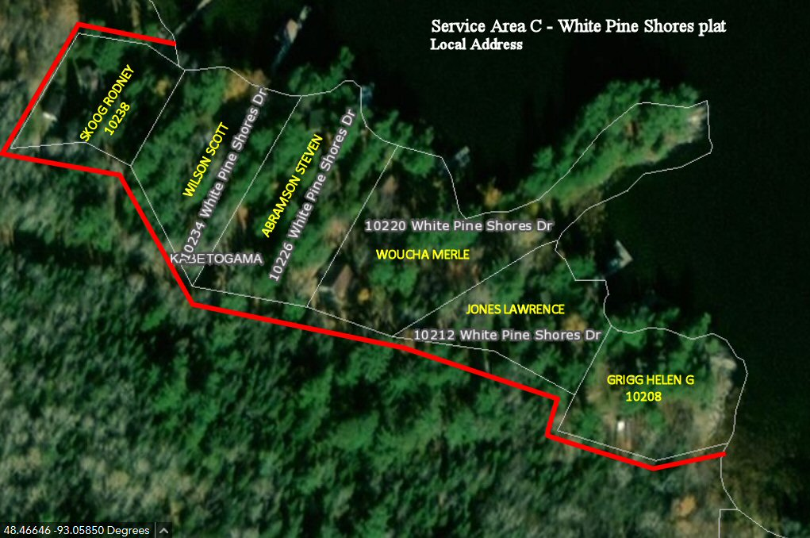

Exhibit B1
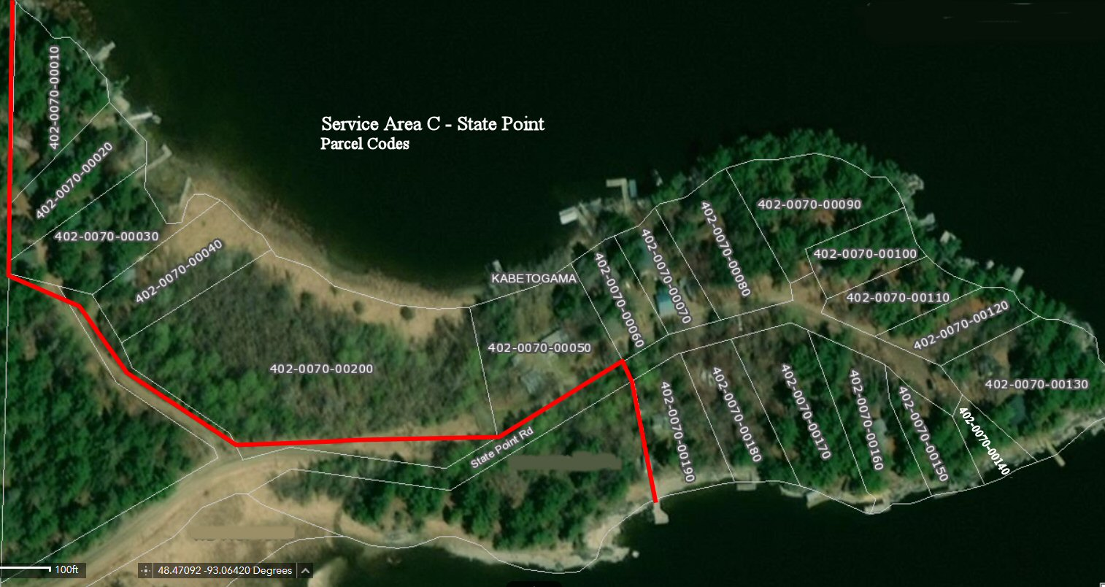

Exhibit B2
