Property Visit Information

View the Namakan Basin Comprehensive Wastewater Plan:
www.kabtownship.org - Kabetogama Clean Water Initiative – Maps and Documents, Draft Comprehensive Wastewater Plan.

1. Reason for the visit
- Raise awareness of wastewater infrastructure problem in Kabetogama. Effluent from existing community sewer infrastructure is reaching our lake and degrading our environment.
- The majority of existing wastewater infrastructure in our community is at some level of noncompliance. (77% - 2010 comprehensive wastewater plan)
- To talk about property owner’s responsibility for maintaining a compliant wastewater treatment system.
- To talk about property owners personal awareness of the impact of a noncompliant system on the environment.
- To talk about problems many property owners face in constructing and/or maintaining a compliant system on their properties.
- To communicate that the conclusion of the 2010 Comprehensive Wastewater Plan that the best and in many situations, the only alternative to comprehensively address our wastewater infrastructure problem is the community sewer system approach. This approach is supported by the Kabetogama Township Board.
- To encourage the property owner, along with neighbors, to support and sign a petition to the Kabetogama Township Board, to form a subordinate service district for the purpose of:
- Organizing a Service Area of property owners into a legal entity (subordinate sanitary sewer district) supported by a unit of government with levy authority (Township), to plan for, construct and operate a community wastewater collection and treatment system for the property owners of that Service Area.

2. Service Area and Individual property Information
- You are in proposed Service ___ .(maps attached)
- There are __ wastewater generating properties in your proposed service area (30 owners) .
- Compliance Criteria (see attached: Table 2 Compliance Criteria Page 10, Kabetogama Chart page 12 Comprehensive Wastewater Plan Namakan Basin Sanitary Sewer Initiative 2010). Table 2 outlines criteria used by the county to broadly determine compliance. The Kabetogama chart shows general level of compliance (2010) by proposed service area.
- Depending on the results of the petition or future petitions, service areas or established subordinate sewer districts may be combined or added to maximize economy of scale for construction and operation.

3. Benefits of a Subordinate Sanitary Sewer District
- Clean Water: Voyageur’s National Park (the Park) is the nation’s only water-based national park, with more than 84,000 acres of water and 134,000 acres of land. The interconnected waterways of the Park provide an unparalleled opportunity for water based recreation and enjoyment of the north woods environment. It’s why people visit our area. It is why we live here, choose to run water based businesses, or to maintain seasonal cabins. Water is our most precious natural resource, the foundation on which all other resources (including us) depend. Unfortunately, those waters are being negatively affected by human impact such as wastewater from existing developments throughout our community. This water quality degradation threatens the long-term health of the ecosystem, the economic health of our tourism industry and it will continue to impair our enjoyment of the area as time goes on.
- An opportunity to become a sustaining member of the Voyageurs National Park
Clean water Community.
Community sewer projects serving the majority of lakeshore properties in Crane Lake and Island View on Rainy Lake have already been completed. Ash River is in the engineering phase of their community sewer project.
- Of the three sister communities in the VNP Namakan basin, Kabetogama Township is the largest wastewater producer. It also contains the most resorts which are typically the largest wastewater producers.
Kabetogama has addressed only a small portion of its wastewater infrastructure improvement needs to date.
- Financially Viable costs for the property owner
There are four identifiable costs to individual property owners as the project proceeds from formation of the Subordinate sewer district through construction to ongoing operation and maintenance.
- Early planning and organization costs
The township will accrue expenses in this early phase for things like mailings, consultation with experts, attorney fees, loan and grant application fees etc. For the Puck’s Point project, this amount came to $50,000.00 for the district over a 10+ year period with many starts and stops. We don’t expect this kind of time frame and will have a much more focused approach so much less should be spent during this phase. Costs accrued during this phase will be apportioned by property and assessed on individual property owner taxes.
- With the creation of a subordinate sewer district, the township can seek grant dollars and low cost loans on behalf of the district to pay for engineering services, land acquisition, financial services, attorney services and construction. Construction includes those components which are part of the community system including grinders, collection system from grinder to the treatment system, treatment system and dispersal system.
- The township will work with service providers to put together a package of grants and loans to cover costs based on best estimates for project.
- The dollar amount the township borrows (loans) is the portion of the capital costs which becomes the responsibility of the township to repay, which is passed on to the individual property owners to repay in annual installments assed on their property taxes as a service fee.
- Capital costs are amortized over a 20 year period.
- There are no connection fees or other associated fees charged to district members when they connect within 90 days of completion of construction.
- May be property owner’s responsibility and expense to connect a building to the grinder.
The public portion of the system ends at the grinder. In the Puck’s Point project, it was part of the project to reconnect existing service lines to the grinder if that existing line was within 10 feet of the installed grinder. Otherwise, the property owner made arrangements to have the supply line from the building to the grinder installed. This cost will vary dependent on length, soil conditions (soil or rock) and whether property owner desires winter operation. The expense for Puck’s Point property owners ranged anywhere from $0 to $10000.00.
- Operation, Maintenance and Replacement cost
- Actual cost of day to day operation of the system plus a fixed annual replacement cost.
- OM&R costs are fixed costs. Whether there are one or a hundred connections, the costs are basically the same. The more connections, the less each connection pays in OM&R fees.
- Individual properties are assessed OM&R costs on the basis of EDU’s assigned to their property. (See EDU explanation attached)
- Cost Control
- The range of individual property owner cost for completed projects in the area (Crane Lake, Puck’s Point, Island View) is approximately $80-$115 per month per EDU ($960-1380 per year per EDU) for OM&R and capital debt reduction combined. Puck’s point is at $90.
Through the planning process, the township will seek guidance from the steering committee and property owners and react if estimated costs become outside an economically feasible range.
- Lower Long Term Costs
- At $100 per month per EDU, the OM&R costs plus capital debt reduction for a single dwelling property over 20 years is $24000. T hen using county estimates of average cost constructing a mound system (serviceable life of 20 years) for a single family dwelling at $20,000.00 plus the cost of pumping the septic tank every 3 years at $1400 and add the cost of financing, the numbers are pretty close. After 20 years, the debt being paid off, the numbers favor the community sewer system.

- Managed Sewer Infrastructure
- The township manages the district and insures that requirements of the operating permit are met, problems are addressed and bills are paid. The property owner’s only responsibility is to maintain the service line from the building to the grinder and to call the township if there is a problem with equipment.
- It is the townships responsibility to maintain compliance with county and state sanitary sewer ordinances and laws.
- Increased Property Value/Salability
- A property with a public sewer has a big plus factor when it comes time to sell.
- No Roadblocks To Building Or Use Permitting Due to Sewer Concerns
- Sewer issues often slow down or prevent building, remodeling, expansion plans due to issues with the individual sewer infrastructure condition or capacity.
- Eliminates Seasonality
- The system, from the grinder to and including the treatment system will be engineered and built to be frost free allowing for year round use.
- Each individual property will control if winter use to their grinder is possible by the design/characteristics of their service line from the building to the grinder.
- More Usable/Aesthetic Property Space
- Space on properties now occupied by a mound/ septic tank becomes available for other uses.
- Odors from ineffective systems eliminated.
- Alternative To A Community System On Many Properties Are Limited
- Rock, type of soil, depth of soil, topography, lot size can eliminate an on- site individual sewer treatment system as an alternative of many properties.
- Holding tanks or a community sewer system may be the only alternatives available to some property owners.
- A large portion of the planning, design, engineering, legal and construction costs are covered by grant dollars.
- The project will seek State and Federal grant dollars.
- For the Puck’s Point project, nearly 90% of the project dollars spent was from grants.
- The remaining dollars came from low cost loans (1% interest for most of the borrowing). The borrowed dollars are repaid over time by the district members. These borrowed dollars are referred to as Capital Debt.

4. Other information
- Time Frame
- The time from subordinate sewer district formation to completed project may be as much as 6 years
- Many communities throughout the state are seeking funds to upgrade sewer and water infrastructure. Obtaining grant dollars takes time and patience.
- Much of the grant dollars we will seek comes through the State bonding process which is generally every 2 years.
- In the Voyageurs National Park Clean Waters project area, Ash River has priority at this time.
- Construction Basics
- Collection lines from the grinders to the treatment area will be installed to a depth of 9 feet. This will be accomplished by directional drilling through rock or soil. This requires digging/blasting large holes at depth in strategic locations to accommodate the drilling machine. Some lines may be able to be placed at depth by trenching.
- Grinder stations are 3 foot or 4 foot diameter cylinders 11 feet deep. In most cases, rock blasting will be required to set these at depth.
- Rock blasting: blasting is downward controlled to fracture the rock in the drill hole or grinder station location. Once the rock is fractured, the pieces are removed from the hole with a backhoe and disposed of off-site.
- All wells in the project area will be located and identified and proper distance maintained from blast area to preclude damage.
- All utilities in the project area will be identified and repaired or replaced if damaged by construction.
- There will be a need for some tree removal. This would be minimal due to directional drilling.
- Blasting is noisy, drilling is noisy, moving equipment is noisy. Construction IS noisy.
- It may be possible to limit active construction time to the fall and spring periods. This was done at Puck’s Point.
- Site rehabilitation/restoration/landscaping will be part of the construction project including project damage to driveways, lawns, utilities and other damage that may occur.
- Grinders will be wired into property owner’s electrical supply.
- Property owner (at their expense) will be required to remove (properly abandon) existing septic tanks when they become connected to the public system (county/ state requirement). Some existing septic tanks may be removed as part of the construction process.
- EDU = Equivalent Domestic Unit
The EDU is the basic measure used for engineering design and for establishing user rates and charges to district members. EDUs are established and assigned by the township (using statewide guidelines) for each property early in the planning process.
- A minimum of 1 EDU per grinder station will be assigned for all users.
- Each property is assigned 1 primary dwelling.
- Additional EDU’s are assigned for additional effluent producing buildings/uses.
- A residential EDU is equal to a commercial EDU.
- The following tables I, II and III describe the structure the township used to assign EDU’s at Puck’s Point:

5. Cost Examples - Predicting individual property costs.
- The cost to individual property owners is expressed as $$$ per EDU per month multiplied by 12 for the annual individual property owners cost.
- Cost is made up of three components:
- Capital Cost: Amount paid to pay off Capital Debt.
- Operation/Maintenance/Replacement Cost: The amount required to operate the system.
- Number of EDUs assigned to the property.
- Capital Cost per month per EDU + OM&R Cost per month per EDU
= Monthly Cost per EDU
- The following examples use $30 per month per EDU for the Capital Cost and
$70 per month per EDU for OM&R Cost for a total monthly cost per EDU of $100. (REMINDER: We won’t know the exact monthly Capital costs until construction is complete and we won’t know the exact OM&R cost until the number of connections is known).
- Example: A (residential) cabin (primary dwelling = 1 EDU) with no other buildings connected to a water system is assigned 1 EDU.
$30 (30 X 1) per month Capital Cost + $70 (70 X 1) per month OM&R Cost
= $100 per month or $1200 per year.

- Example: A (residential) cabin ( primary dwelling = 1 EDU) with a guest cabin
(.6 EDU) is assigned a total of 1.6 EDUs.
$48 (30 X 1.6) per month for Capital Cost + $112 (70 X 1.6) per month for OM&R Cost = $160 per month or $1920 per year.

- Example: A resort with one primary dwelling (1 EDU) plus Three 2 bedroom cabins (3 X .6 = 1.8 EDUs) plus two 3 bedroom cabins (2 X .7 = 1.4 EDUs) is assigned a total of 4.2 EDU’s .
$126 (30 X 4.2) per month for Capital Cost + $294 (70 X 4.2) per month for OM&R Cost = $420 per month or $5040 per year.

EXAPLE: Puck’s Point EDU establishment tables
TABLE I
Residential Users |  | EDU Value
Primary Dwelling |  | 1.00
3.02 Residential EDU Combined with Non-residential EDU. The following table provides the EDU assignments on all classes of residential use combined with non-residential or commercial use:
TABLE II
Residential Use Combined with Non-residential or Commercial Use* |  | EDU Value**
Primary Dwelling with Cabin |  | 0.60
Primary Dwelling with Apartment |  | 0.60
Primary Dwelling with Sauna |  | 0.00
Primary Dwelling with Garage |  | 0.00
Primary Dwelling with Garage / Storage Building and Bathroom |  | 0.40
Primary Dwelling with Commercial Accessory Building |  | 1.00
*See Table III for EDU assignments to non-residential and commercial uses.
**The EDU value will be added to the EDU(s) assigned to the Primary Dwelling pursuant to Table I in Section 3.01.
3.03 Commercial Equivalent Domestic Unit. The following table provides the EDU assignments on all classes of Non-residential Users and Commercial Users:
TABLE III
Non-residential Users / Commercial Users |  | EDU Value
 | Apartment | 0.50
 | Bait Shop | 1.00
 | 1 Bedroom Cabin  2 Bedroom Cabin  3 Bedroom Cabin | 0.60  0.70  0.80
 | Commercial Accessory Building | 1.00
 | Garage / Storage Building and Bathroom | 1.00
 | Garage/Storage Building/Boathouse w/o Water | 0.00
 | Public Showers / Laundry / Sauna Building | 1.00
 | Restaurant / Bar (Restroom allocated separately) | 0.20
 | Restroom | 1.00
 | Room (motel/lodge) | 0.50
 | RV with sewer and water hook-up | 0.70
 | RV without sewer and water hook-up | 0.00
 | RV – Dump Station | 0.28
 | Vacant Lot | 0.00

Compliance Criteria: From 2010 Comprehensive Wastewater Plan
Notes
- Holding tanks can now be compliant – need alarm system, records of pumping submitted to county annually.
- Outhouse/privy can now be compliant – need sealed vault, regular pumping
- Ages updated (9 years from 2010)

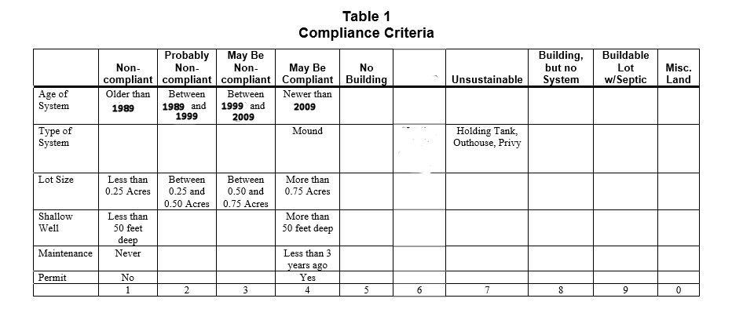
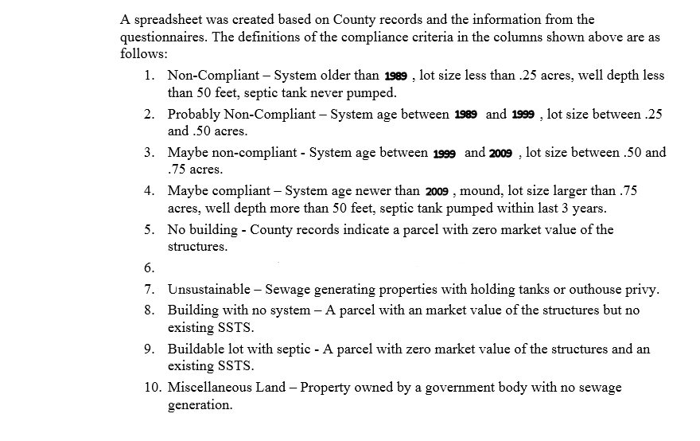

According to Minnesota Rules Chapter 7080.1500, systems installed after March 1996 or in a designated shoreland area must have a minimum of 3 feet vertical separation between the system and groundwater or bedrock. If the system is outside of a designated shoreland area and installed before April 1996, this separation is reduced to 2 feet. This requirement means that most systems installed before March 1996 are not compliant because of the prevalence of bedrock and the high local groundwater elevation.
Based on the Compliance Criteria listed above, the following is a summary of the findings for the Kabetogama Planning areas (from 2010 evaluation criteria).

NOTE: Noncompliance doesn’t necessarily mean a system is not functioning properly – it means that by the criteria used, because of age, type of system or site characteristics the system would not meet current county requirements.

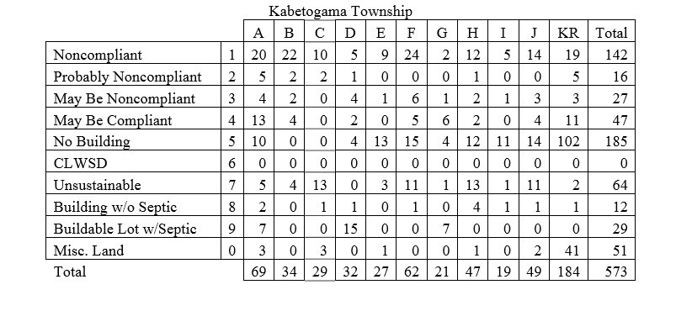

AREA F
